1. **PURPOSE:** Hydraulic oil cleaning and maintenance of ELC
2. **SCOPE:** Door Lifting power pack, , Stamping Station, Battery Machines 1&2.
3. **RESPONSIBILITY:** Engineer in charge and contract workmen on the job
4. **PPEs to be used:** Helmet, Safety shoes , hand gloves, Reflector jacket, and safety goggle
5. **Activities:**

**Activity 1: Draw oil sample**

**Activity 2: Oil patch test**

**Activity 3: Check for water content in the oil**

**Activity 4: Oil cleaning**

**Activity 5: Draining Cleaned oil from the tank**

**Activity 6: Replacement of collectors/ filter**

1. **Aspect- Impact**

**Aspect: -** Oil Spillage, Used O-rings, Used Oil (Generation of Hazardous waste), Used cotton waste, Used filter elements.

**Impact: -** Land Contamination, Resource Depletion.

1. **Hazards Identified**

Physical Hazard : Pressure, electrical

Chemical Hazard : NIL

Mechanical Hazard : Contact, Entanglement, Falling

Ergonomics Hazard : Poor plant/ work area layout

Health Hazard : Exposure/ contact of oil to eye

Human behaviour aspect of operators:

* Alcoholism.
* Casual approach.
* Horse play.
* Non usage of PPE’s
* Improper Housekeeping
* Height Phobia

1. **Procedure:**

**Equipments/ Apparatus:**

1. **ELC:**

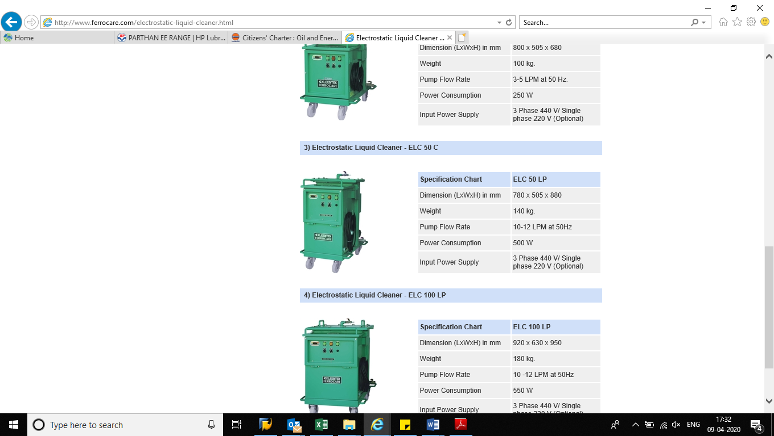

1. **Contamination checking kit**

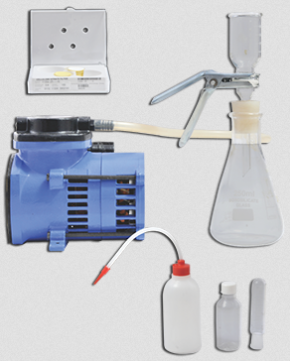

Activity 1: Draw oil sample

* Take electrical shutdown of mobile equipment (on which ELC is installed)
* Open the sampling cock of the ELC
* Take 30cc sample of oil from the oil tank in a clean glass /plastic test tube

Activity 2: Oil Patch test

* Take the conical flask and insert porous base with rubber stopper. Try to keep the end of the porous base below the vacuum suction branch of the conical flask, by pushing the porous base through the stopper.
* Put a Millipore filter patch (0.8 micron) on the porous base and wet it with a little solvent to keep it in place. Use forceps for handling the patch.
* Clamp the measuring funnel over the porous base.
* Connect the vacuum pump suction hose to the branch pipe of the conical flask.
* Start the vacuum pump and filter required quantity of oil.
* Wash the filter with solvent through the funnel so that oil is not carried in the patch.
* Unclamp the measuring funnel and put it away.
* Wash the filter paper gently again by spraying solvent through the flushing bottle with the vacuum pump still on.
* The filter patch should be dried by gently lifting one edge with forceps provided.
* To keep and preserve the patch, lift it off the porous base with a 25 mm transparent tixo tape. The filter patch will stick to the gummed side.
  + If the patch test is clear WHITE <indicates purity o.5mg/100ml> (no visible dust collected on filter) oil can be considered definitely clean having contaminants less than 0.5 micron as expected purity of hydraulic oil. In this case all 30 cc oil should pass through the filter without blocking the filter.
  + If patch test shows

Black colour patch approx. contaminants level(10mg/100ml) Brown colour patch -do- (4mg/100ml )

Dark Yellow colour patch -do- (2mg/100ml)

Faint Yellow colour patch -do- (1mg/100ml)

COLOUR with some visible particles of dirt then the hydraulic oil needs to be cleaned. Particles can be checked under microscope in case of doubt with 50X magnification. Under such conditions 30 cc oil will not pass through the filter. This oil needs to be cleaned immediately.

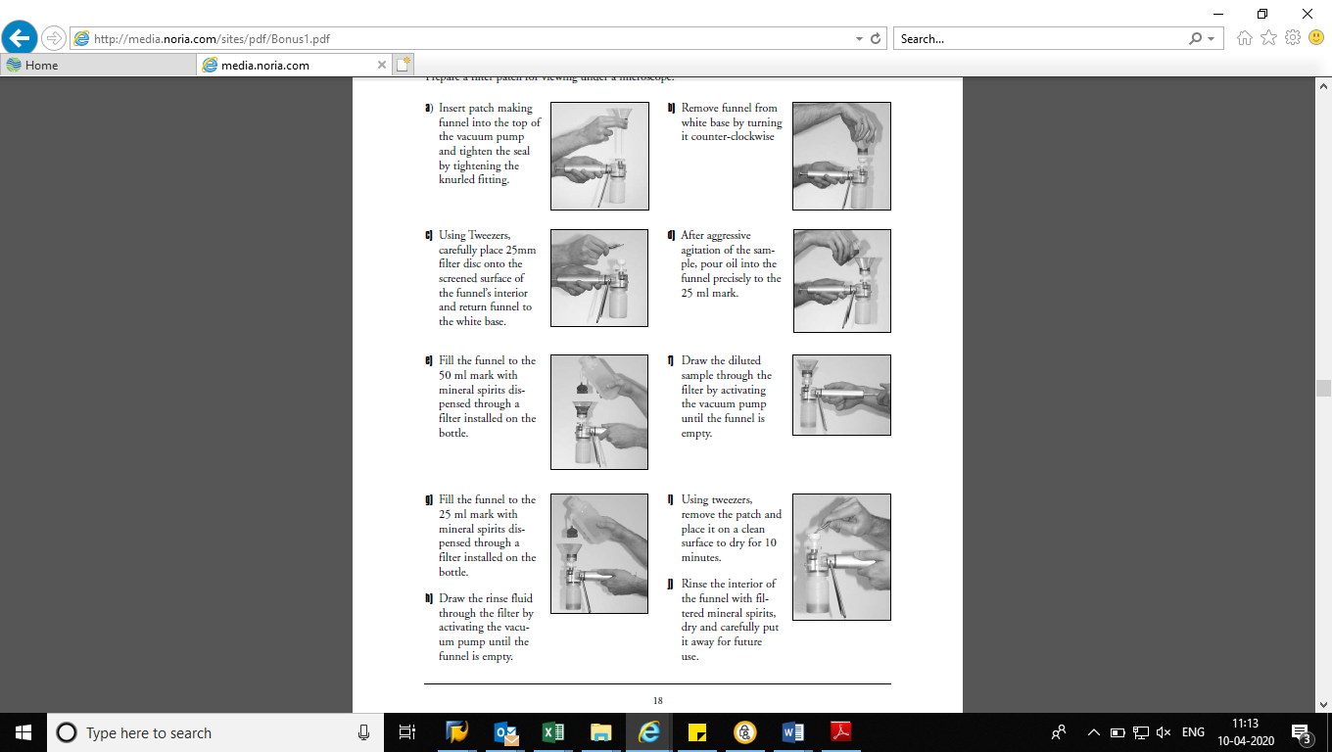

Activity 3: CHECK FOR WATER CONTENT IN THE OIL

* Before connecting ELC for oil cleaning it is very much essential to check water content in the oil
* Switch on the heater till the smoke /white fumes are seen from the heater pan.
* Carefully put few drops of oil on hot pan .
* If the bubbles keep coming and do not disappear presence of water is confirmed .
* Excess water in oil also gives crackling sound. One has to be very careful whileconducting this test to avoid burn injury to human skin.

**Activity 4: Oil Cleaning**

**Before starting the machine ensure the following**

1.      Confirm that oil temp and moisture content are within specified limits.

2.      Check the power switch of the ELC is off

3.      Confirm that the collectors are in place and cover is fastened uniformly.

4.      Shut the drain valve and open sampling valve.

5.      Ensure suction line is fully immersed in oil.

6.      Check both suction and discharge lines are connected to tank and tightened properly.

7.      Open Flow control valve in line after the pump.

8.      Press the FWR button to bring the pump to forward operation during cleaning of oil and REV Button during draining.

* Take electrical shutdown of mobile equipment (on which ELC is installed)
* Connect suction pipe of ELC to the reservoir tank of power pack for which oil to be cleaned.
* Connect delivery pipe of ELC to return line of the power pack.
* Press the start button. Both LED “Start” and “FWR” should be on during filtering.
* Switch on the pump & see that flow is in desired direction .This can be confirmed by opening sample cock or see through outlet hose.
* The ELC will start and the pump will fill the tank with oil. The float switch gets activated as the top level is reached. The pump will automatically stop when the cleaning cell tank is filled with oil. The pump will automatically restart after the preset interval and cleaning will start.
* If tank of ELC before connecting is empty. Top up 50 lit of fresh oil to avoid low oil level in the power pack.
* Allow ELC to run for same system for at least seven days (Or based on contamination level in the oil).
* When the ELC is continuously operated for a long time, it is advisable to discharge about 1 litre of oil from the drain valve at an interval of 50 Hrs. This ensures discharge of heavy contaminants from the drain.
* After specified period of oil cleaning press the stop button of the ELC machine. LED display will switch off to indicate pump stoppage.

**Activity 5: Draining Cleaned oil from the tank**

* Take electrical shutdown of mobile equipment (on which ELC is installed)
* Place suitable plastic or Aluminium tray under the Y type strainer of suction hose of ELC.
* Unscrew the cap of the Y type strainer remove wire mesh and clean.
* Replace the wire mesh after cleaning and retighten the cap of the strainer.
* Open air cock on the top cover of the cleaning tank.
* Open the control panel door and set internal toggle switch ON
* Set the FWR/REV to reverse.
* Press the start button to start pump in reverse direction and drain off the oil tank.

**Activity 6: Replacement of collectors/ filter**

1.      The life of collectors depends on the contamination level. A rough indication of collector life for ELC 50 C is 4000-5000 litters in 1500-2000 hrs

2.      Take electrical shutdown of ELC machine. Follow one man one lock system and use of LOTO box.

3.      Unscrew all bolts of the cleaning tank cover and remove the contaminated corrugated type collectors and electrode covers.

4.      Remove electrodes and clean with cotton waste. Use tray to avoid oil spillage.

5.      Replace electrodes in its place and change both collectors.

6.      Tighten all bolts of the cleaning tank cover.

7.      Remove all oil soaked cotton waste, hand gloves; Used filters to the designated place.

8.      In case of oil spillage, clean the same, sprinkle saw dust and scrape the surface and shift saw dust to designated place.

**Precautions and hints**

1. The solvent should be a light and safe solvent. Petroleum Ether is recommended. It is also sold as Hexane. Pet Ether with a low boiling point will help faster testing, whereas a higher boiling point will be more useful for dissolving the oil. The choice is left to the user.

2. The solvent should be filtered over ordinary filter paper first . This will conserve the 0.8 micron patches which are costly.

3. Then it should be filtered over 0.8 micron paper in required quantity.

4. For viscous oils first take the required quantity of oil and dilute it with solvent about 2 to 3 times the volume. If this is not done, oil will take a long time yo pass thru the patch. Use cleaned solvent for dilution.

1. **REFERENCES: Manual for ELC machine operation & maintenance, Manual for Contamination checking kit, SP45**
2. **RECORDS:**

|  |  |  |  |  |  |
| --- | --- | --- | --- | --- | --- |
| **Sr. No.** | **Record No.** | **Record Title** | **Maintained by** | **Soft/Hard form** | **Retention Time** |
| 1. | - | Parameter tracking | BM Incharge | Hard | 1 yr |
| 2. |  | Patch test | BM Incharge | Hard | 1 yr |
| 3. |  | Oil analysis | BM Incharge | Hard | 1 yr |
| 4. | HI/08 | Hazard Identification | IMS | Soft | 1 yr |
| 5. | RA/08 | Risk Analysis | IMS | Soft | 1 yr |
| 6. |  |  |  |  |  |

|  |  |  |  |
| --- | --- | --- | --- |
| **Date** | **Manual Section Ref. & Para** | **Brief details of Revision** | **New Rev.** |
| 13-08-2022 | Header | Company logo & Document no. | 6 |
|  |  |  |  |
|  |  |  |  |

|  |  |  |
| --- | --- | --- |
| **Prepared By:**  Head Mechanical Maintenance, Battery 1- MCD | **Reviewed & Issued By:**  Management Representative | **Approved By:**  Head Mechanical Maintenance MCD |
| **Signature:** | **Signature:** | **Signature:** |
| **Review Date: 13.08.2022** | **Review Date: 13.08.2022** | **Review Date: 13.08.2022** |